---------------------how to create Enum file ----------------------

https://www.itsolutionstuff.com/post/how-to-use-enum-in-laravelexample.html

https://www.designcise.com/web/tutorial/how-to-get-values-of-all-backed-enum-cases-as-an-array-in-php

1. app--> Enums--> UserRole.php

<?php

namespace App\Enums;

use App\Traits\EnumAccessorsTrait;

enum UserRole:string {
use EnumAccessorsTrait;

case Customer = 'customer'; //Customer is a name and customer is a value
case Admin = 'admin';
case Manager = 'manager';
}

2. use file in blade

use App\Enums\UserRole;

$manager->role = UserRole::Manager;

if (UserRole::Customer->value == 'customer') {

if ($request->plan == PlanFrequency::Monthly->value || $request->plan == PlanFrequency::Annually->value) {

3. how to acces particular enum case?
Ans: PlanFrequency::Annually i--> output name and value both
if you want to get only value

PlanFrequency::Annually->value)

4. how to access all enum variables

$pract = UserRole::cases();
dd($pract);

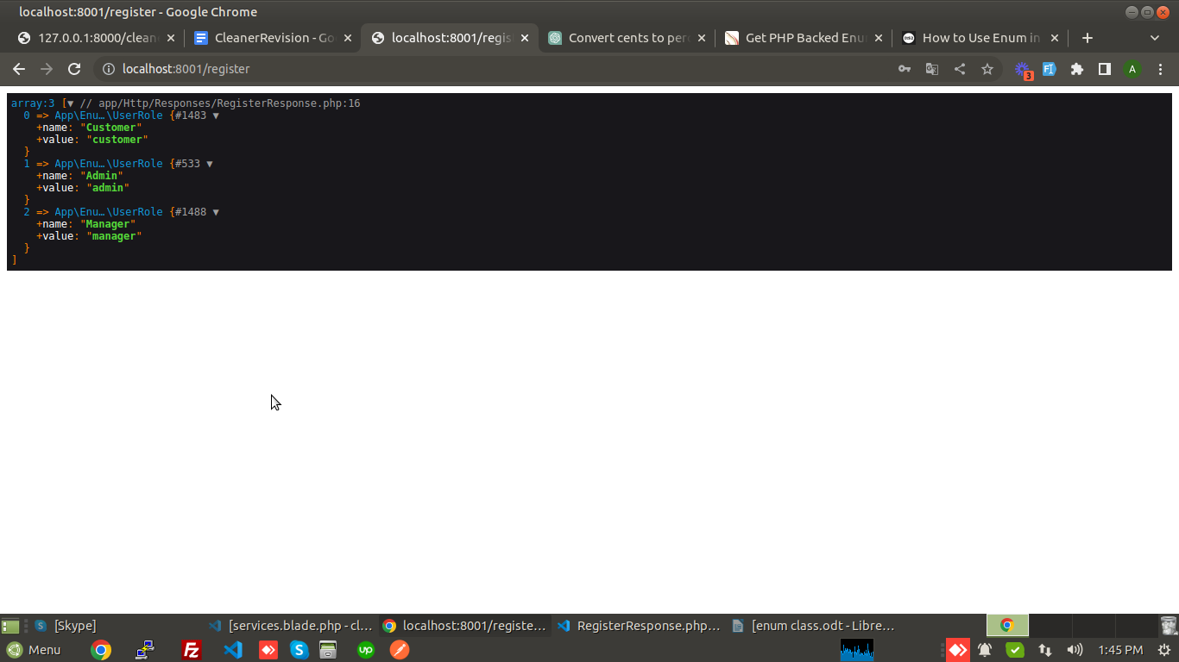

5. in db table save enum value , now how to show key from value in frontend?

Means
eg: case Customer = '1’;
case Admin = '2';

in table save 1, 2 value , when we access data from db it will get 1, 2 value but we want to show key according to value in enum.
Ans: UserRole::fromValue($user->type)->description

UserRole is enums name , $user variable that get value from db and type is column name ,
fromValue is a static method that returns the corresponding role object based on a given value, and description is a property or method of the role object that returns its description,

---------------------------

rufff work in complete

// if ($user->role->value == 'customer') elseif ($user->role->value == 'admin')
if (UserRole::Customer->value == 'customer') {

if ($request->plan == "monthly" || $request->plan == "annually") {

return redirect()->route('card');
} else {

return redirect()->route('plans');
}

} elseif (UserRole::Admin->value == 'admin') {
return redirect()->route('admin.dashboard');
}

